Model I EX 요구사항

* Customer 관련 :회원가입, 로그인, 정보수정, 로그아웃, 회원리스트보기
* 고객센터(파일첨부게시판) – 글쓰기, 답변글쓰기, 글목록(페이징추가), 글수정, 글 삭제
* 도서등록, 도서리스트보기(페이징), 도서상세보기
* 로그인한 사람만 도서등록과 글쓰기(원글, 답변글)가 가능하다
* 글수정은 내가 쓴 글만 수정 가능하다.
* 글삭제는 내가 쓴 글이 아니여도, 로그인전이여도, 삭제용비번만 알면 삭제 가능
* header의 gnb와 footer의 배경색은 #003300

실행화면 캡쳐

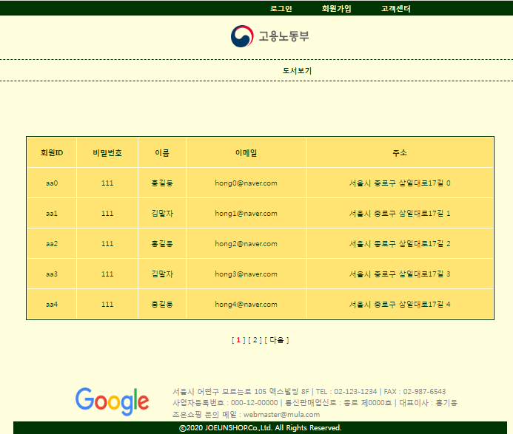 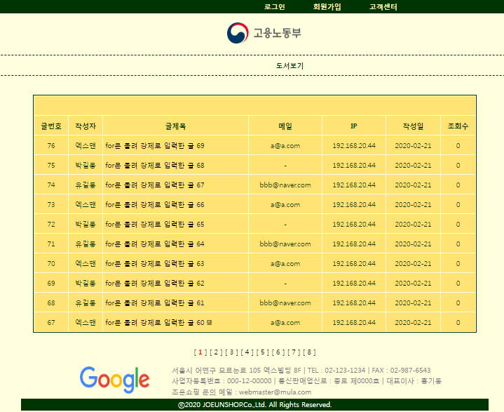

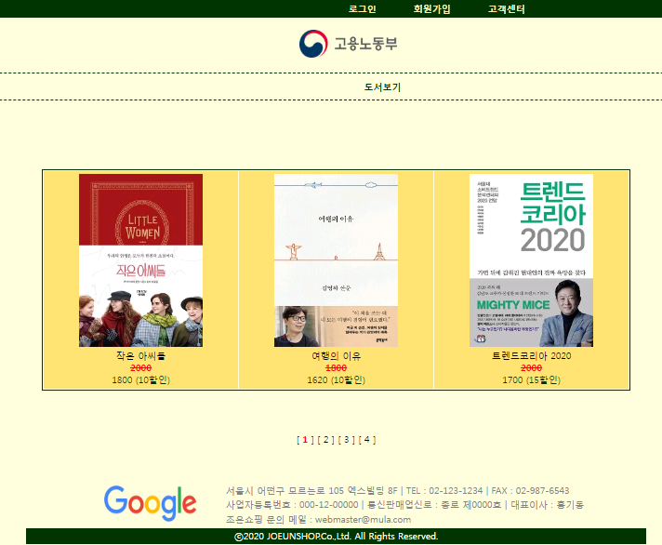 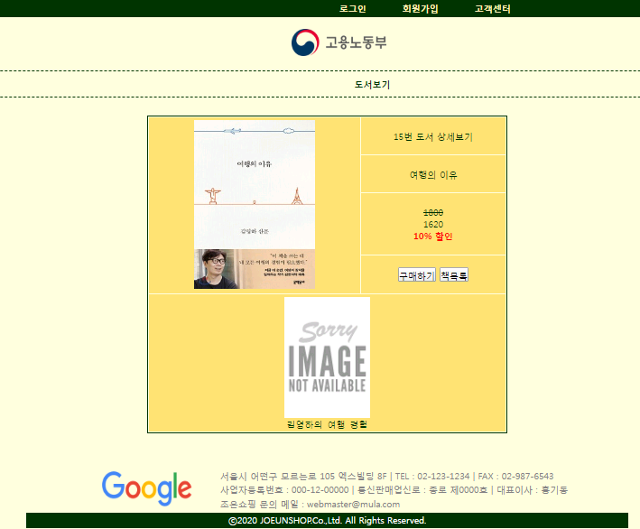

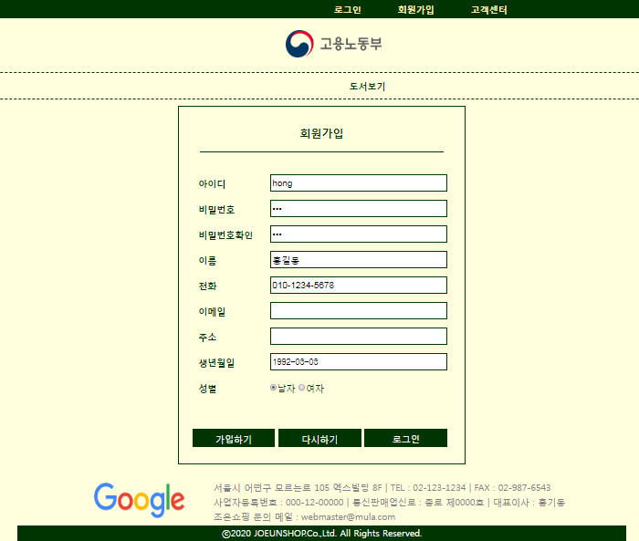 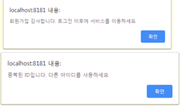

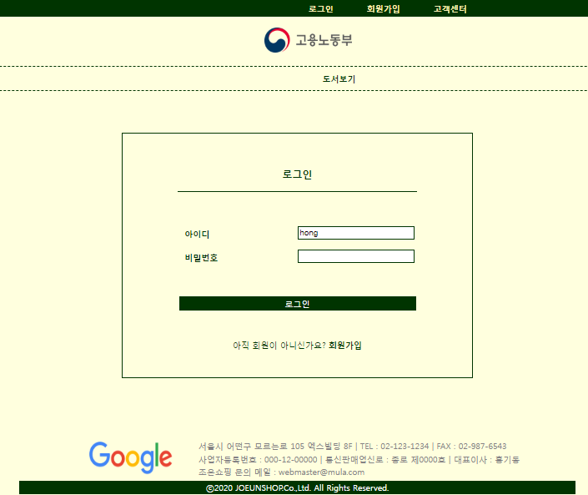 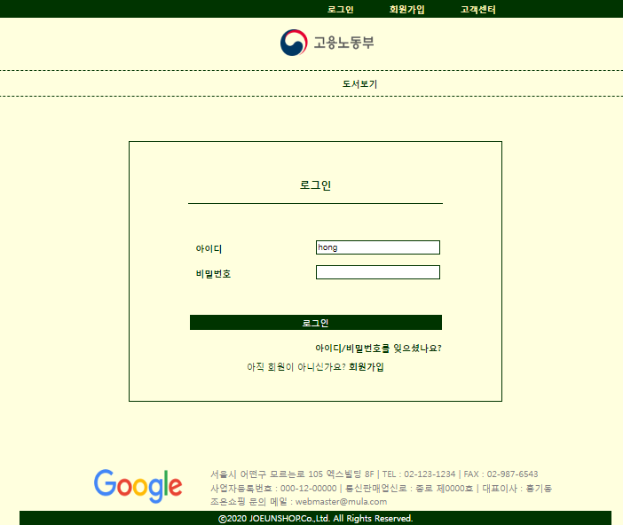

로그인 후 해더 변경, 도서등록 메뉴 생기고 글쓰기 생김

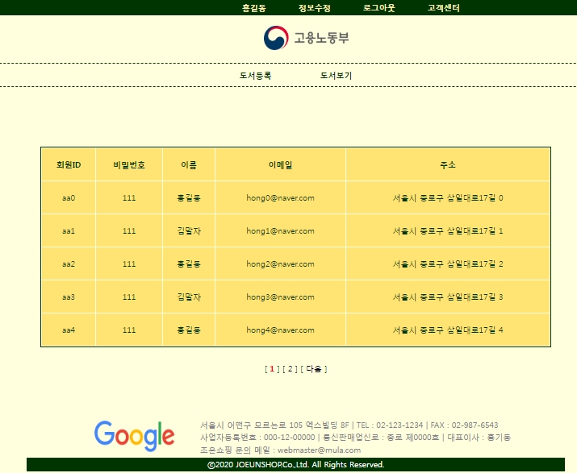 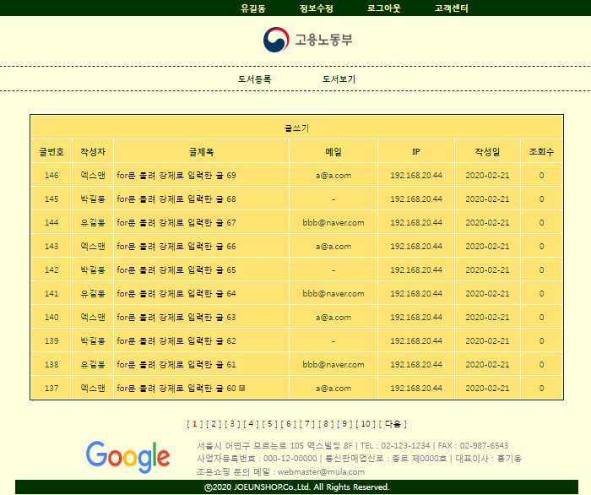

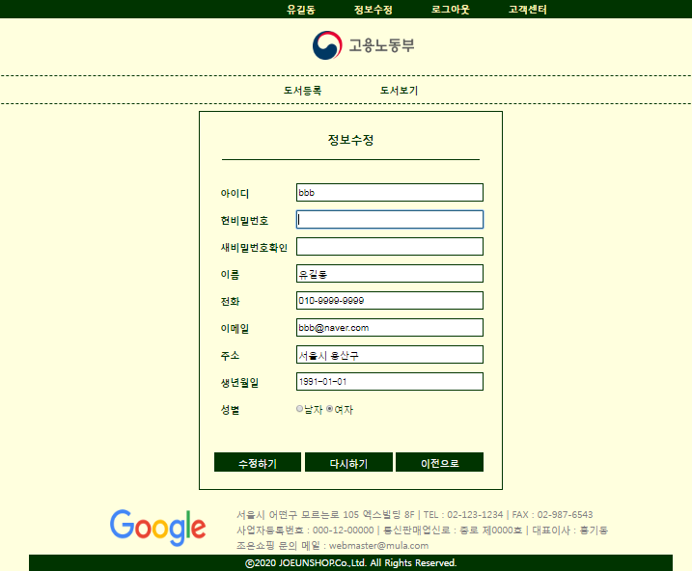 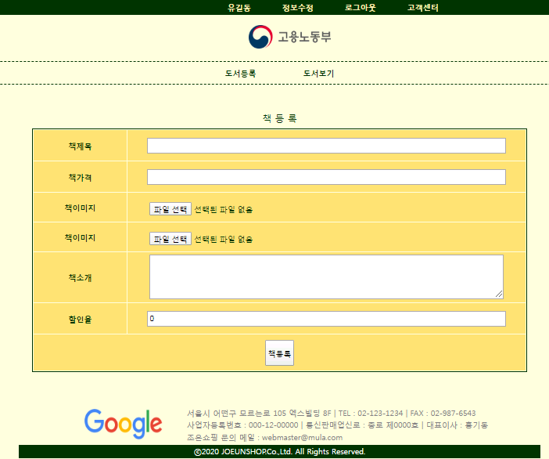

* 로그인 전 글 상세보기 페이지엔 답변버튼이 없다. 내가 쓴 글이 아니면 수정버튼도 없다
* 첨부파일이 없을 경우 “첨부파일 없음”라고 출력
* 로그인 한 후 고객센터 게시판 : 수정(본인 글만 수정), 답변(로그인 후), 삭제(비번알면 타인글도 로그인 전도 가능)

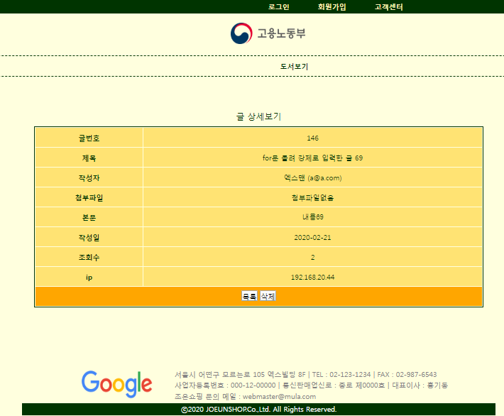 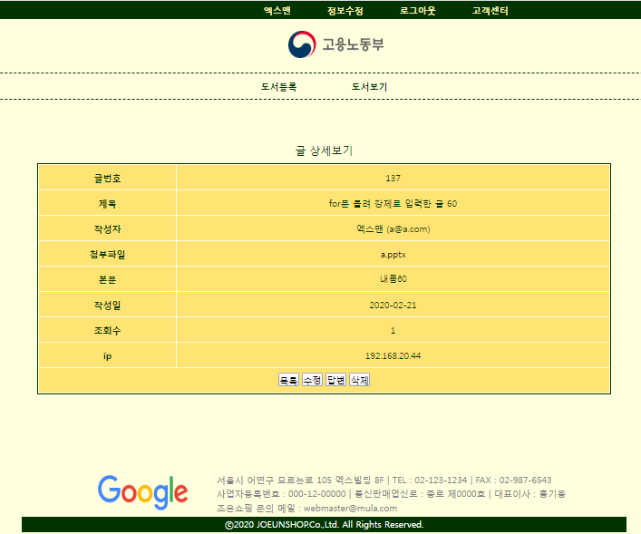

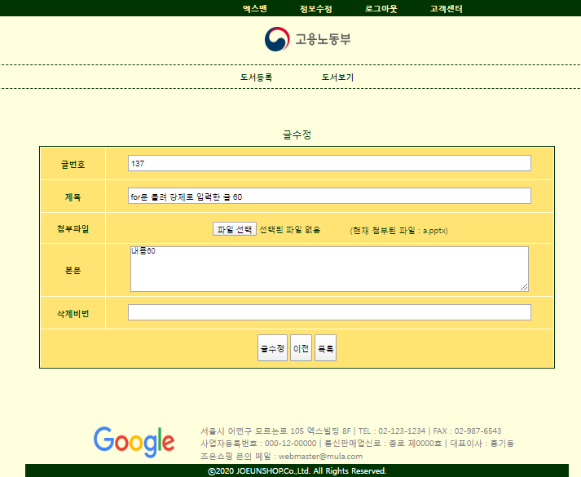 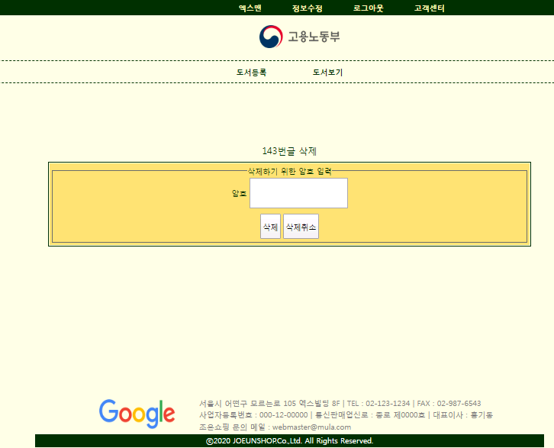

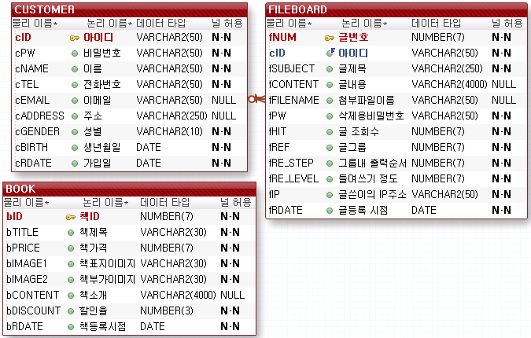

프로젝트 구성요소

* DTO3개(BookDto,CustomerDto,FileboardDto), DAO 3개(BookDao,CustomerDao,FileboardDao)는 src폴더에 아래의 폴더는 WebContent폴더에
* img 폴더 - 이 프로그램에서 필요한 이미지들(로고, hot.gif, level.gif, re.gif, fileup.jpg)
* main 폴더 - footer.jsp
* header.jsp
* main.jsp(첫화면)
* customer폴더 - joinForm.jsp
  + - * + joinPro.jsp
        + loginForm.jsp
        + loginPro.jsp
        + logout.jsp
        + modifyForm.jsp
        + modifyPro.jsp
* book폴더 - bookList.jsp
  + - * bookRegister.jsp
      * bookRegisterPro.jsp
      * bookContent.jsp
* bookImg폴더 - 도서등록시 업로드할 파일들이 저장될 폴더
* fileboard폴더 – fboardList.jsp
  + - * + fboardContent.jsp
        + fboardDeleteForm.jsp
        + fboardDeletePro.jsp
        + fboardUpdateForm.jsp
        + fboardUpdatePro.jsp
        + fboardWriteForm.jsp
        + fboardWritePro.jsp
* fileboardUpload 폴더- 파일첨부게시판에서 첨부한 파일들이 저장될 폴더
* 그 외 css

**(WebContent/css/footer.css)**

@charset *"UTF-8"*;

**footer** {overflow:*hidden*;width: *1000px*;margin: *0* *auto*;}

**footer** **div** { float:*left*; height: *90px*;}

**footer** **div***.office_logo* {width: *300px*;text-align: *center*;}

**footer** **div***.office_logo* **img** {

margin-left:*100px*;

width:*150px*;

height: *60px*;

padding:*20px*;

}

**footer** **div***.office_address*{ width:*700px*;}

**footer** **div***.office_address* **ul**{ margin: *15px* *20px* *20px* *20px*;}

**footer** **div***.office_address* **ul** **li**{

padding:*2px*;

color:*gray*;

font-size: *0.8em*;

list-style: *none*;

}

**footer** **div***.copyright*{

clear: *both*;

border: *0*;

width: *1000px*;

height: *25px*;

margin: *0* *auto*;

background-color: *#003300*;

color: *white*;

text-align: *center*;

line-height: *25px*;

font-size: *0.9em*;

}

**(WebContent/main/footer.jsp)**

<%@ page language=*"java"* contentType=*"text/html; charset=UTF-8"*

pageEncoding=*"UTF-8"*%>

<% String conPath = request.getContextPath(); %>

<!DOCTYPE html>

<html>

<head>

<meta charset=*"UTF-8"*>

<title>Insert title here</title>

<link href=*"*<%=conPath %>*/css/footer.css"* rel=*"stylesheet"*>

</head>

<body>

<footer>

<div class=*"office_logo"*>

<img src=*"https://www.google.com/images/branding/googlelogo/1x/googlelogo_color_272x92dp.png"*>

</div>

<div class=*"office_address"*>

<ul>

<li>서울시 어떤구 모르는로 105 엑스빌딩 8F | TEL : 02-123-1234 | FAX : 02-123-1233</li>

<li>사업자등록번호 : 000-12-00000 | 통신판매업신로 : 강남 제0000호 | 대표이사 : 홍길동</li>

<li>조은시스템 문의 메일 : webmaster@mula.com</li>

</ul>

</div>

<div class=*"copyright"*>

ⓒ2022 JOEUNSYSTEM.Co.,Ltd. All Rights Reserved.

</div>

</footer>

</body>

</html>

**(WebContent/css/header.css)**

@charset *"UTF-8"*;

*{padding:*0*; margin: *0*;}

**body** {

background-color: *lightyellow*; font-size: *9pt*;

}

**header** **a** {text-decoration: *none*; font-weight: *bold*;}

**header** **li** { list-style: *none*;}

**header** *.gnb*{width: *100%*; background-color: *#003300*;}

**header** *.gnb* **ul** {

overflow: *hidden*;

width:10*00px*;

height: *30px*;

line-height: *30px*;

margin: *0* *auto*;

}

**header** *.gnb* **ul** **li** { float: *right*; margin-right: *30px*;}

**header** *.gnb* **a** {

color : *#FFF0B5*;

font-size: *0.9em*;

display: *block*;

padding-left:*15px*;

padding-right:*15px*;

}

**header** *.logo*{

width:*120px*; text-align:*center*;

margin: *20px* *auto*;

cursor: *pointer*;

}

**header** *.lnb* {

width: *100%*;

border-top: *1px* *dashed* *#003300*;

border-bottom: *1px* *dashed* *#003300*;

}

**header** *.lnb* **ul**{

overflow: *hidden*;

width:*300px*;

margin: *0* *auto*;

}

**header** *.lnb* **ul** **li** {

margin: *5px*;

float:*right*;

padding:*5px* *40px*;

line-height: *25px*;

}

**header** *.lnb* **a** {

height:*1.1em*;

color: *#003300*;

font-size:*1.1em*;

margin-bottom: *20px*;

}

**(WebContent/css/style.css)**

@CHARSET *"UTF-8"*;

*#content_form* **table** {border: *2px* *solid* *#003300*; width:*95%*; margin: *10px* *auto*;}

*#content_form* **table** **tr** { background-color: *#FFE271*; height:*40px*; }

*#content_form* **table** **tr***:hover* { background-color: *orange*;

cursor: *pointer*;

}

*#content_form* **td,** *#content_form* **th** {text-align: *center*; padding:*5px*; }

*#content_form* **caption** {font-size: *18px*; padding:*10px*;}

*#content_form* **h2,** *#content_form* **b**{text-align: *center*; color:*red*;}

*#content_form* **a** { text-decoration: *none*; color:*black*}

*#content_form* *.left*{text-align: *left*;}

*#content_form* *.paging* {text-align: *center*;}

*#content_form* **input***:not*(*.btn*)**,** *#content_form* **textarea** {

width: *90%*;

}

*#content_form* **input** {height: *20px*; padding:*3px*; margin: *10px* *0*;}

*#content_form* *.btn* {height: *30px*; padding:*3px*; margin: *5px* *0*;}

*#content_form*{

width:*1000px*; margin: *0px* *auto*; height: *500px*;

text-align: *center*;

color: *#003300*;

padding-top:*100px*;

}

**(WebContent/css/join.css)**

@charset *"UTF-8"*;

*#joinForm_wrap* {width:*430px*; margin: *10px* *auto*; border: *1px* *solid* *#003300*; padding:*20px*;}

*#join_title*{

width:*400px*; margin:*10px* *auto*;

padding-bottom:*20px*; border-bottom:*1px* *solid* *#003300*;

color:*#003300*; font-size:*1.5em*;

text-align:*center*; font-weight:*bold*;

}

*#joinForm_wrap* **table**{margin:*0* *auto*; color:*#003300*;}

*#joinForm_wrap* **table** **tr**{height:*40px*; }

*#joinForm_wrap* **table** **th**{

width:*120px*; font-size:*0.9em*;

color:*#003300*; text-align:*left*; padding-left:*10px*;

}

*#joinForm_wrap* **table** **td** {width: *300px*;}

*#cid***,** *#cpw***,** *#cpwChk***,** *#cname***,** *#ctel***,** *#cemail***,** *#cname***,** *#caddress***,** *#cbirth* {

border: *1px* *solid* *#003300*; height:*20px*; width:*95%*; padding:*3px*;

}

*.joinBtn_style* {

color: *#ffffff*; background: *#003300*;

border:*0*; outline: *none*;

width:*32%*; padding:*5px* *0*;

}

**(WebContent/customer/joinForm.jsp)**

<%@ page language=*"java"* contentType=*"text/html; charset=UTF-8"*

pageEncoding=*"UTF-8"*%>

<% String conPath = request.getContextPath(); %>

<!DOCTYPE html>

<html>

<head>

<meta charset=*"UTF-8"*>

<title>Insert title here</title>

<link href=*"*<%=conPath%>*/css/join.css"* rel=*"stylesheet"*>

<script>

**function** chkJoinInfo(){

**if**(frmJoin.cpw.value!=frmJoin.cpwChk.value){

alert('비밀번호를 확인하세요');

frmJoin.cpw.value = '';

frmJoin.cpwChk.value = '';

frmJoin.cpw.focus();

**return** **false**;

}

}

</script>

</head>

<body>

<jsp:include page=*"../main/header.jsp"*/>

<div id=*"joinForm_wrap"*>

<form action=*"joinPro.jsp"* method=*"post"* name=*"frmJoin"* onsubmit="return chkJoinInfo()">

<div id=*"join_title"*>회원가입</div><br>

<input type=*"hidden"* name=*"hiddenParam"* value=*"xx"*>

<table>

<tr>

<th><label for=*"cid"*>아이디</label></th>

<td><input type=*"text"* name=*"cid"* id=*"cid"* required=*"required"*></td>

</tr>

<tr>

<th><label for=*"cpw"*>비밀번호</label></th>

<td><input type=*"password"* name=*"cpw"* id=*"cpw"* required=*"required"*></td>

</tr>

<tr>

<th><label for=*"cpwChk"*>비밀번호확인</label></th>

<td><input type=*"password"* name=*"cpwChk"* id=*"cpwChk"* ></td>

</tr>

<tr>

<th><label for=*"cname"*>이름</label></th>

<td><input type=*"text"* name=*"cname"* id=*"cname"* required=*"required"*></td>

</tr>

<tr>

<th><label for=*"ctel"*>전화</label></th>

<td>

<input type=*"tel"* name=*"ctel"* id=*"ctel"* required=*"required"* value=*"010-"*>

</td>

</tr>

<tr>

<th><label for=*"cemail"*>이메일</label></th>

<td><input type=*"email"* name=*"cemail"* id=*"cemail"*></td>

</tr>

<tr>

<th><label for=*"caddress"*>주소</label></th>

<td><input type=*"text"* name=*"caddress"* id=*"caddress"*></td>

</tr>

<tr>

<th><label for=*"cbirth"*>생년월일</label></th>

<td><input type=*"date"* name=*"tempbirth"* id=*"cbirth"* required=*"required"*></td>

</tr>

<tr>

<th>성별</th>

<td>

<input type=*"radio"* name=*"cgender"* value=*"m"* checked=*"checked"* id=*"m"*><label for=*"m"*>남자</label>

<input type=*"radio"* name=*"cgender"* value=*"f"* id=*"f"*><label for=*"f"*>여자</label>

</td>

</tr>

<tr>

<td colspan=*"2"*> </td>

</tr>

<tr>

<td colspan=*"2"*>

<input type=*"submit"* value=*"가입하기"* class=*"joinBtn_style"*>

<input type=*"reset"* value=*"다시하기"* class=*"joinBtn_style"*>

<input type=*"button"* value=*"로그인"* class=*"joinBtn_style"*

onclick="location.href='login.jsp'">

</td>

</tr>

</table>

</form>

</div>

<jsp:include page=*"../main/footer.jsp"*/>

</body>

</html>

**(WebContent/css/login.css)**

@charset *"UTF-8"*;

*#loginForm_wrap* {

width:*430px*;

margin: *75px* *auto*;

border : *1px* *solid* *#003300*;

padding:*50px* *100px*;

}

*#login_title*{

text-align: *center*;

margin:*10px* *auto*;

padding-bottom: *20px*;

border-bottom: *1px* *solid* *#003300*;

color:*#003300*;

font-size: *1.5em*;

font-weight: *bold*;

}

*#loginForm_wrap* **table** {margin: *0* *auto*;}

*#loginForm_wrap* **table** **tr**{height: *40px*;}

*#loginForm_wrap* **table** **th**{

width: *120px*;

color: *#003300*;

text-align: *left*;

padding-left: *10px*;

}

*#loginForm_wrap* **table** **td** {

width:*500px*;

}

*#cid***,** *#cpw* { border: *1px* *solid* *#003300*; width: *95%*; padding: *3px*;}

*#loginForm_wrap* **table** **tr** *#login_findIdPw*{

height: *20px*;

text-align: *right*;

font-size: *0.8em*;

font-weight: *bold*;

color:*#003300*;

}

*#loginForm_wrap* **table** **tr** *#login_findIdPw:hover*{ cursor:*pointer*;}

*#loginForm_wrap* *#login_join*{

text-align: *center*;

color:*#003300*;

font-size: *.9em*;

}

*#loginForm_wrap* *#login_join* **a** {

text-decoration: *none*;

color:*#003300*;

font-weight: *bold*;

}

*.loginBtn_style*{

color:*#ffffff*;

background-color: *#003300*;

border-style: *none*; outline:*none*;

width: *100%*; height: *120%*; padding:*3px*;

}

**(WebContent/customer/loginForm.jsp)**

<%@ page language=*"java"* contentType=*"text/html; charset=UTF-8"*

pageEncoding=*"UTF-8"*%>

<%

String conPath = request.getContextPath();

String msg = request.getParameter("msg");

%>

<!DOCTYPE html>

<html>

<head>

<meta charset=*"UTF-8"*>

<title>Insert title here</title>

<link href=*"*<%=conPath%>*/css/login.css"* rel=*"stylesheet"*>

</head>

<body>

<jsp:include page=*"../main/header.jsp"*/>

<div id=*"loginForm_wrap"*>

<div id=*"login_title"*>로그인</div>

<form action=*"loginPro.jsp"* method=*"post"*>

<table>

<tr><td> </td></tr>

<tr>

<th><label for=*"cid"*>아이디</label></th>

<td><input type=*"text"* name=*"cid"* id=*"cid"*

required=*"required"* autofocus=*"autofocus"*

value=*"*<%

String cid = (String)session.getAttribute("cid");

**if**(cid!=**null**){

out.print(cid);

}

%>*"*></td>

</tr>

<tr>

<th><label for=*"cpw"*>비밀번호</label></th>

<td><input type=*"password"* name=*"cpw"* id=*"cpw"* required=*"required"*></td>

</tr>

<tr><td colspan=*"2"*>&nbsp;</td></tr>

<tr><td colspan=*"2"*><input type=*"submit"* value=*"로그인"*

class=*"loginBtn_style"*></td></tr>

<tr>

<td colspan=*"2"*>

<%**if**(msg!=**null**){ %>

<p id=*"login_findIdPw"*>

아이디/비밀번호를 잊으셨나요?</p>

<%} %>

</td>

</tr>

</table>

<p id=*"login_join"*>아직 회원이 아니신가요? <a href=*"join.jsp"*>회원가입</a></p>

</form>

</div><br>

<jsp:include page=*"../main/footer.jsp"*/><%--jsp실행한 결과 가져옴 --%>

</body>

</html>

**(WebContent/book/bookRegister.jsp)**

<head>

<meta charset=*"UTF-8"*>

<title>Insert title here</title>

<link href=*"*<%=conPath%>*/css/style.css"* rel=*"stylesheet"*>

<style>

*#content_form*{

height: *550px*;

padding-top:*50px*;

}

</style>

</head>

**(WebContent/fileboard/fboardList.jsp) (WebContent/fileboard/fboardContent.jsp)**

<head>

<meta charset=*"UTF-8"*>

<title>Insert title here</title>

<link href=*"*<%=conPath%>*/css/style.css"* rel=*"stylesheet"*>

<style>

*#content_form*{

height: *570px*;

padding-top:*30px*;

}

</style>

</head>

**(WebContent/fileboard/fboardUpdateForm.jsp) (WebContent/fileboard/fboardWriteForm.jsp)**

<head>

<meta charset=*"UTF-8"*>

<title>Insert title here</title>

<link href=*"*<%=conPath%>*/css/style.css"* rel=*"stylesheet"*>

<style>

*#content_form*{

height: *550px*;

padding-top:*50px*;

}

</style>

</head>